Game Design Document  
*Giuseppe Evangelista*

Contents

General Info 1

Genre 1

Target Audience 1

Gameplay Overview 1

Key Moments 2

Art, Sound & Music 2

Competitive Analysis 2

Monetization 2

General Info  
In my semester of game design, I plan to make a game called Lightspeed, a 2D platformer with a focus on fluid movement and getting through levels as fast as possible (speedrunning).

Currently, the game is still being designed. As I write this, I have a very basic movement system up and running in unity, but most of the level design and abilities still need to be designed.

Right now, the plan is to release the game on PC (Itch.io specifically, since Steam costs money) once done. If time allows it, I may consider a Nintendo Switch port.

Genre  
fgsfd

Target Audience

Gameplay Overview  
The gameplay is split into two sections: Camp and Levels.

The Camp section is where you are placed before a level or upon booting up the game. When you start the game up for the first time, you are placed directly in the first level (the tutorial), after which you reach an encampment of survivors. This area will function as the hub for the game. Here you may exchange currency to rebuild parts of the survivor camp, converse with survivors, upgrade your character (balancing and concepts still a WIP) and most importantly, select levels. Which leads me into the next section:

Levels are split up into 5-7 (WIP) “rooms”. These rooms provide a bite-sized platforming section as well as serving the function of checkpoints. At the start of a level, you will get a certain amount of lives. Upon getting hit in any way, you lose a life and go back to the start of the room. Losing all lives means going back to the camp. While all this happens, a timer is at the top of the screen with an indicator of your current rank. At the end of the final room, a little victory animation will play while your rank is displayed. Rewards will be obtained, a new level will be unlocked and you will be sent back to the camp.

While most levels adhere to this philosophy, boss levels are a bit different. They have all the same attributes as the other levels, except that an enemy will be actively aiming for you or making the environment move to your detriment. To reach the next “room/checkpoint” you must hit the boss after dodging his attacks. At that point the boss will retreat ahead into the level, rinse and repeat until the boss loses all their health. Boss levels reward you with tons of currency and a new ability (WIP if this ability may be used in earlier levels).

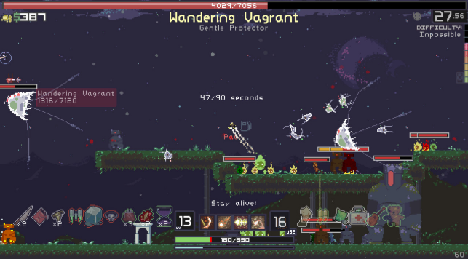Art, Sound & Music  
The game will have a stylized, pixel art style similar to Risk of Rain (See image).

The environment will mostly be medieval ruins overgrown with green vegetation in normal levels, whereas boss levels trade that in for more alien, spiky purple landscapes.

The main character and survivors will be stylized characters with a very small amount of pixels, while bosses will be a bit bigger. IF time allows it, I may consider making stylized character arts in my art style (mix of western stylization and anime).

The entire game will use the colours white and yellow signifying the main character and “good things” and black and indigo to symbolize the blight and “bad things” (for examples, obstacles will nearly always be indigo to facilitate players sightreading the level). In general, the colours will be saturated and bright.

For the sound design: yeah I got to research this come back to this later

Now for the music: I’ve been playing piano for 10 years now, and have been officially composing for 2 years now. As such, I will be composing the soundtrack for this game myself. I’ll probably make a simple piano piece for the title screen theme, a relaxing guitar + piano piece for the survivor camp, a track for the first level and a track for the boss level. So 4 tracks in total (for this semester).

Key Moments  
Dump ideas for key moments here:  
1. Start of the game  
I was thinking of starting the game in a semi-dark temple, where you learn the controls (the controls will be engraved into pillars or sum), and the music keeps getting more instruments, and then when you exit the temple the title of the game flashes and the music actually starts, and the actual light colour palette gets used.

2. Have the NPC’s play an instrument each?   
Maybe have the NPC survivors have instruments they play, and as you build up the town more instruments get added/new sections to the song

3. The entirety of the boss stage  
I want all the atmosphere, rain, pianos, a banger theme, and most important: music syncs. And most importantly, Ethereal wings leitmotif EVERYWHERE.

Competitive Analysis  
Something something there aren’t that many speedrunning games (sole focus), and neon white is 3d, so I wanted to make something like that but in 2d.  
Also pogoing in hollow knight as a parkour mechanic is awesome so yeah Ill do that too

MDA  
The main aesthetic I am going for is the feeling of going fast, feeling in control of a speed demon and most importantly: **to feel like you’re improving your time.**

The main dynamics I want to implement that follow this are extremely precise movement (playing a platformer with bad controls and asked to be precise is a nightmare) and the ability to take different routes. To achieve this, I want to try to design levels that have multiple ways to get to the goal. With that I don’t mean branching paths, more something along the lines of pogoing off a spike to save time instead of taking a safer path. So designing levels that feel streamlined yet offer time saves is my goal.

The mechanics for the fluid movement would be implanting smooth acceleration and deceleration, jumping (duh), wall jumping and dashing (8-directional, standardized). For the multiple-path level design, it’ll be putting in as many choices as possible in my levels, so the player actually feels like they’re choosing their own path to be faster.

Monetization  
fgsfd